MICRO MOUSE MAZE

Team Description Paper-50 points

Rules & Regulations

1. All the questions are to be answered.
2. Each answer fetches you 5 points.
3. Good Video fetches you 30 points.
4. All TDP’s to be submitted in .pdf format only.
5. File to be named as “teamname_maze2019.pdf” e.g. “xyz_maze2019.pdf”.
6. Only one TDP submission per team.
7. A team will not be allowed to participate if the robots are different from the design described in the TDP.
8. Last date for TDP submission is 29/12/2019 by 11:59 p.m.
9. Selections for the prelims will be done based on the TDP’s.
10. Coordinators have the right to select and reject any of the TDP’s.
11. If the TDP is selected for further rounds, Team members can be changed only after intimating the coordinators in advance.
12. Decision of coordinators is final and binding on all participants in case of discrepancies.
13. All queries to be mailed to [maze@shaastra.org](mailto:maze@shaastra.org).

Team Name:

|  |  |  |  |  |
| --- | --- | --- | --- | --- |
| Shaastra ID: | Name: | Institute Name: | Mobile No: | Email ID: |
| SHA1906689 | Nandhini S R | National Institute of Technology Trichy | 9444722376 | srnandhini1108@gmail.com |
| SHA1906678 | Hemangani N | National Institute of Technology Trichy | 6379526694 | nhemangani@gmail.com |
|  |  |  |  |  |
|  |  |  |  |  |

Make a video Describing the Mechanism of your bots. (Mention SHAASTRA 2019 Maze), upload it to YouTube and put the video link here.

The video’s Google drive link has been submitted in the website.

The video is also attached in the mail here.

Thank you

**Answer all the 4 questions below with the maximum of 100 words.**

1) What components and mechanisms were used in the build of your Robot? Briefly explain why you choose them?

Components used in the build of Micro-Mouse Robot:

1 Arduino Uno, 2 battery_HW Hi Watt, 3 ultrasonic sensors_ HC-SR04, 1 Opto-coupler encoder_ LM393,

1 L298N 2A Based Motor Driver Module, 2 DC motors, 2 wheel_radius-3cm, 1 caster wheel, Chassis, Wires,

Breadboard.

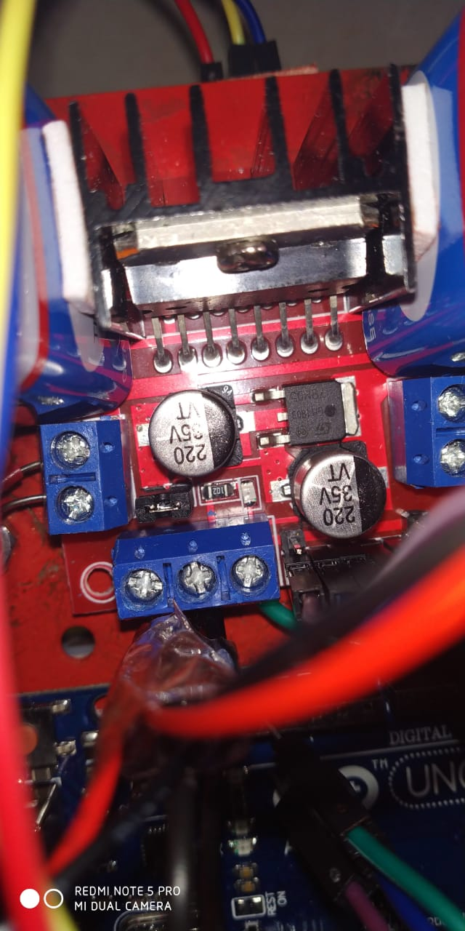 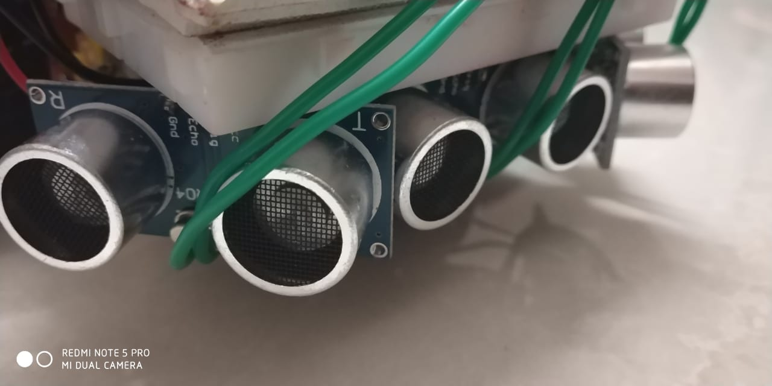 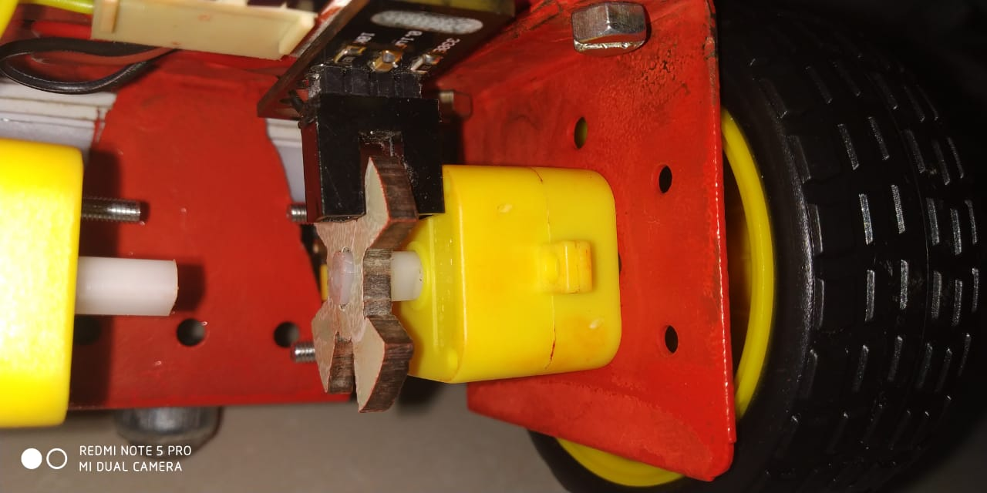

L298N 2A Based Ultrasonic Sensor HC-SR04 Opto-coupler encoder_LM393

Motor Driver Module

Micro-Mouse Robot

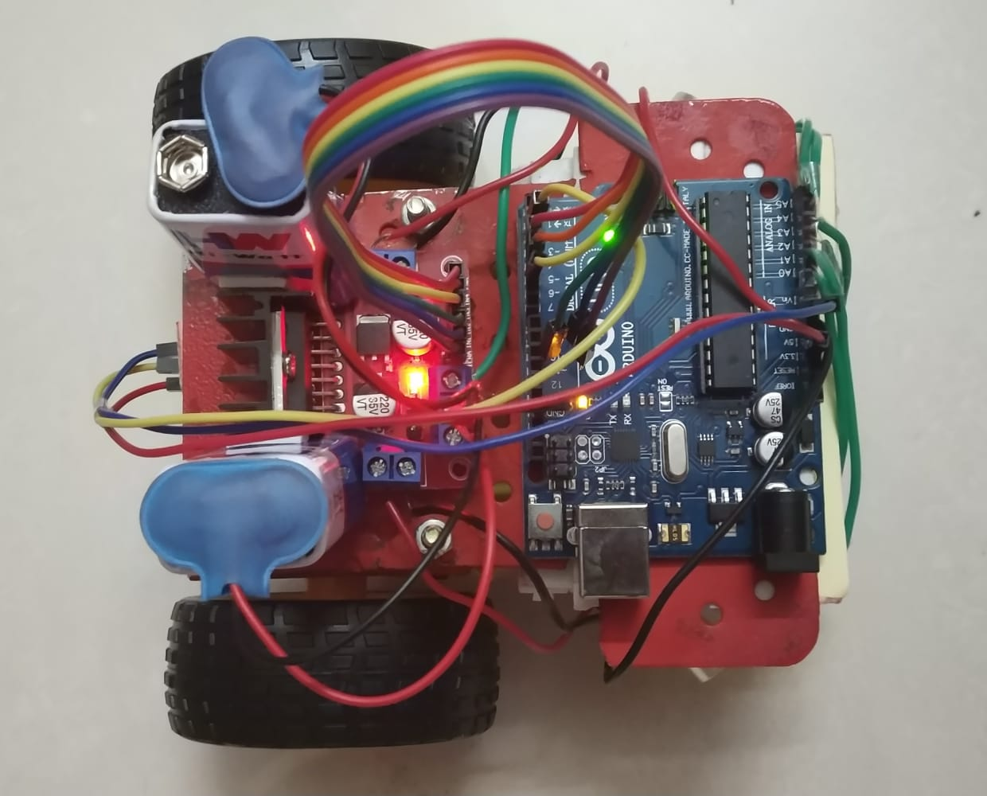 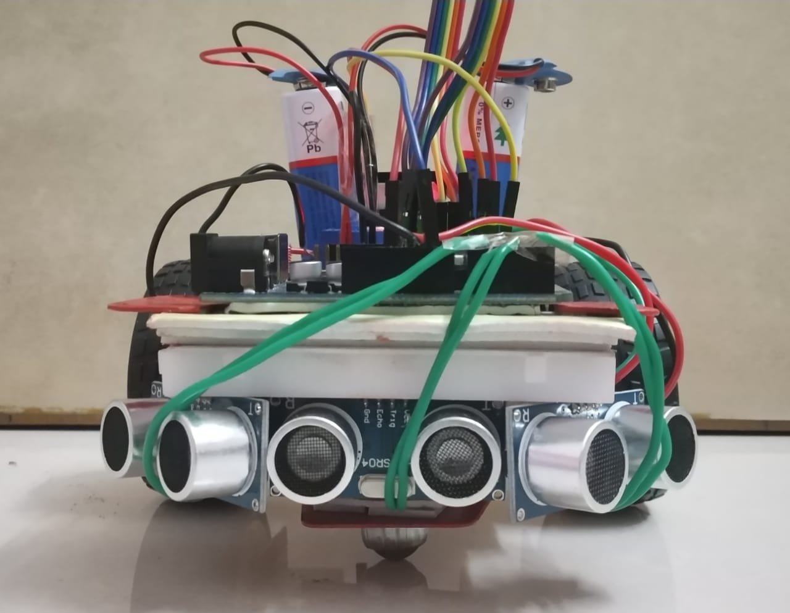 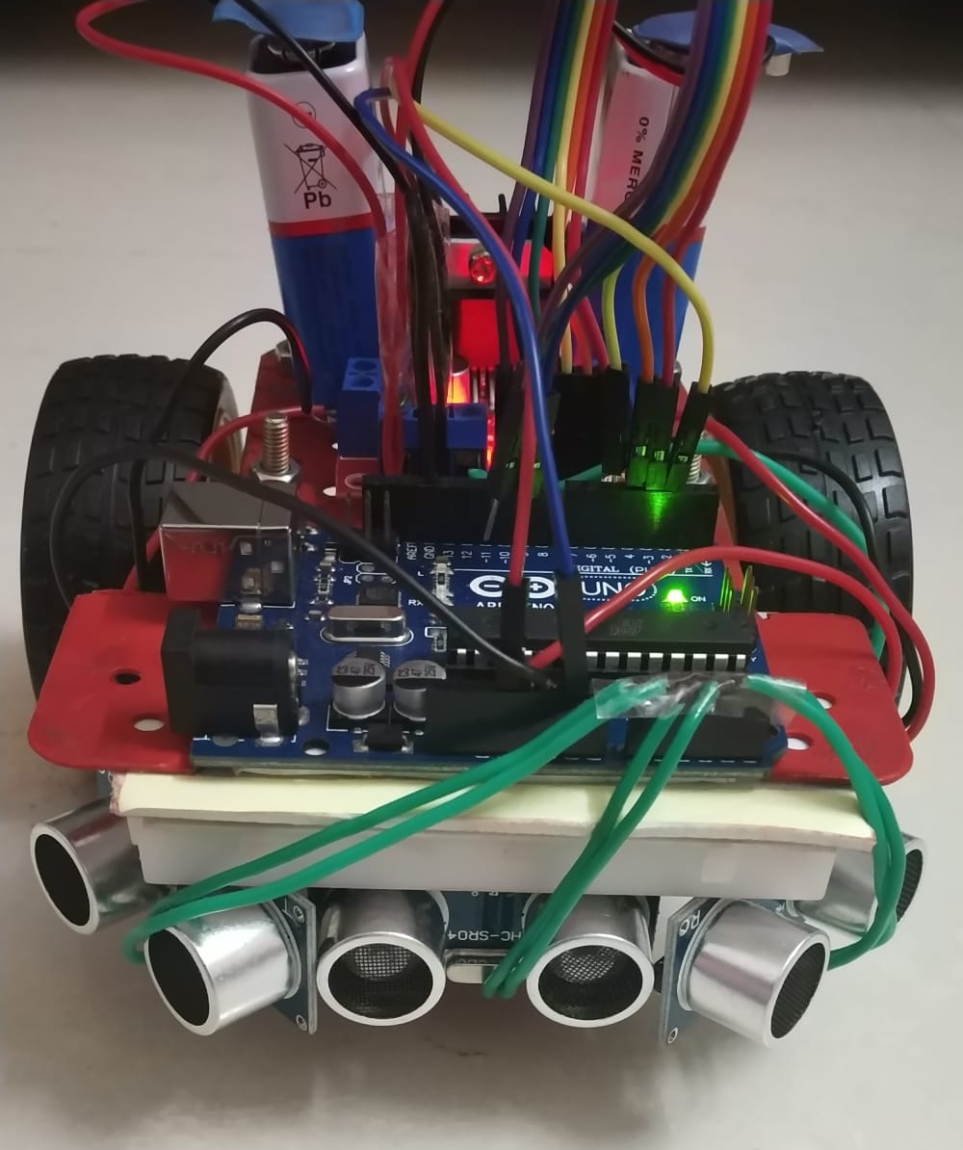

Mechanisms and Reasons for choice of components:

The Kinematics, Locomotion and physical interaction of this autonomous maze solving robot to change its state relative to the environment is coordinated by Ultrasonic Sensors, Encoders and motor driver for the wheels to rotate and enable the smooth run of micro-mouse robot.

The Ultrasonic Sensor HC-SR04 sends a pulse triggered in the trigger pin, which gets reflected from the obstacle and is received by the echo pin. The calculated time-span between emitting and receiving signals enables us to measure the distance and detect the presence of the wall. The change of direction and the movement of the robot is controlled by the Opto-coupler encoder whose state of pin alters on encountering an obstruction in the path of Infra red light. This enable us count the number of rotation of wheel to calculate the distance travelled by the robot and in turn find the location of the micro-mouse in the maze. Also the encoder count enables the rotation of micro-mouse to exact 90 degrees. Hence, with the power being supplied to micro-mouse through the Motor driver the speed and rotation of both wheels can be controlled which allows for the navigation of the micro-mouse in the maze by detection of all walls to reach the destination.

2) Briefly describe the algorithm used to function the bot as per the given Problem Statement.

The Algorithm used to function the bot is the further modified version of the Modified Flood Fill Algorithm.

The Flood Fill algorithm works by assigning value for all nodes in the maze, where these values indicate the steps from any cell to the destination node. Once the micro-mouse reaches a particular node it updates its flood value to 1 + minimum flood value of the open neighbour node and moves to the node which has the smallest flood value. The Modified Flood Fill Algorithm is the further extension of the Flood Fill algorithm where the flood value of the present node is updated only if required to do so else continues its motion in a greater pace.

We further extended the logic of implementation and analysed an efficient way to store and remember the nodes which needs to be followed in the final run to travel to the destination node in the shortest time. Hence after propagating the flood values to all the adjacent neighbouring nodes (only if the present node’s flood value is updated, propagation takes place) the flood value of the present node is checked. Not every node travelled by the micro-mouse robot but only the nodes which is 1 less than the flood value of the previously stored node’s flood value, is pushed to the dynamically allocated stack for keeping track of the preferred path to destination cell. In this way only one final exact path to the destination node will be stored which solves the algorithm to solve the entire maze by the micro-mouse maze efficiently.

3) Any innovative ideas in your design that you think would give you an edge over others?

2 additional ideas in the design of the micro-mouse robot implemented includes:

1. Use of opto-coupler encoder for improving the accuracy and precision of the robot during locomotion. The counter value of the encoder maps the location of the micro-mouse with respect to the maze. Also, the increment of the counter value enables the appropriate rotation to 90 degrees. The movement of the right wheel forward keeping the left wheel stationary allows left turn and back movement of the right wheel allows right turn. Hence attaching an encoder to the right wheel enables to keep track of the counter which allows the exact Right, Left and U turns.
2. Improvising the Modified Flood Fill algorithm is undoubtedly an added innovative idea.

We first check the flood value of the current node. If it needs to be updated, it updates the flood value of the current node and pushes the current node into the stack along with its open neighbour nodes. It further checks if the flood value of open neighbours nodes needs to be updated. If their flood values also need to be updated it pushes their open neighbour cells also into stack and updated flood value propagates further until a stable state is reached and the stack is empty.

Now comes the important logic of keeping track of the nodes to reach the destination node. Once the flood value is propagated, the current flood value is checked with the flood value of the last stored element dynamically allocated stack memory which keeps track of nodes to be travelled in the final run. Only if the current flood value is 1 less than the flood value of the last stored stack element, it is pushed into the stack. Hence this removes the possibility of remembering all the nodes travelled by micro-mouse and stores only one final path to keep track of the nodes to reach the destination node.

4) Any comments or suggestions?

Applauds to the Shaastra team for providing a conveniently accessible web page for registrations and acquainting the participants with overall happenings of the fest.

We just thought, the Maze description, TDP requirements and Presentation requirements could have been specified better and event schedule could have continued with its pre-defined dates and timings.

Overall, all set fine before the event and looking forward to the event day for a new learning experience.

Note: It is recommended that your TDP includes Pics of the robot or the mechanisms that you are going to implement.